**Cost report presentation**

**Cost model**

The aim of this document is to show the process and philosophy behind the costing method used for the FSAE Cost Event.

***Context and hypothesis***

*Company description*

The simulated company is sized to be a prototyping shop, able to manufacture and assemble most of the components of an FSAE car. Therefore, it will not have in-house specific expensive machinery used for a unique or only few parts of the car. For instance, 3D stereolithography printer used for the air intake, water-jet cutter, …

Of course, the machinery will not be used all the year to build only one FSAE car. Thus, we assume that the remaining time where the equipment is not allocated for the FS project is used for other customers, to build another car, small/medium series of components, prototypes, …

The same hypothesis is used for manpower.

Therefore, the shop is built around:

* Administrative department for marketing, production support (materials orders, invoice, …), finance, …
* Several shop floor workstations:
  + A 3 axis Haas CNC Mill VF-3SSYT
  + A CNC mill with Y axis Haas ST35-Y
  + A CNC laser table FL510HD-1000 from Baileigh
  + An assembly station
  + A welding station
  + A conventional machining area with a mill and a lathe
  + A metrological lab
  + FAO workstations

*Hypothesis*

The following assumption are used in the cost model:

* The shop is running 35 hours a week, 46 week per year.
* During the opening time, machines are considered to have an OPE reflecting downtime, preventive maintenance, lack of orders, …
* Manpower of the shop floor are considered to work 95% of the time

Items are attributed a linear depreciation between 3 to 10 years regarding equipment type.

In this simulation is not included:

* Building expense: rent, security, insurance
* VAT for the purchased and sold products
* Governmental taxes
* Margin applied on sell products

*Cost model division*

It has been chosen to divide the model in several parts.

* Overhead costs : Include all the equipment and expenses needed to run the company.
* Manufacturing cost :
  + Machining cost : Equipment like CNC mill and lathe cost are detailed. This cost is added to manpower and overhead cost.
  + Assembly cost : This part use cycle time for operation, mix to overhead and manpower cost to reflect the price of assembly.
* Bought parts :
  + Materials
  + Fasteners

*Sources*

The cost is built on reliable source to ensure the quality of the model. Machine prices came from Baileigh industrial, Haas machining. Informatic equipment from HP. Metrology equipment are sourced from Mitutoyo, Starrett and Orexad… This is also applicable to fasteners and materials.

*General data*



Operator are considered to be skilled machinist. Thus, he could manage a CNC machine and program simple parts.

***Overhead cost***

The overhead cost includes all the equipment and expenses needed to run the company.

Therefore, it takes into account office furniture, items used for different workstations, administrative wages, manpower time used for maintenance purpose, energies cost for small machinery and offices, …

This overhead is then distributed equally between each workstation production in order to annually compensate the overhead expense of the company.



***Manufacturing cost***

For each equipment, a fixed cost is built around machine, tooling, fixture prices and maintenance cost dedicated to the workstation. It is depreciated as the overhead is. Then is added variable cost like electricity cutting fluid, filler and tools. A ratio is determined to link a machining data (volume, length) to execution time. Finally, it is possible to associate a cost on each operation.

*Milling and turning*

For both milling and turning, a machine has been selected from Haas catalogue to fulfil most of the production need for the FSAE prototype. A Y axis lathe with live tooling has been preferred to a classic CNC lathe as it allows more versatile machining like sprocket machining and reduce the number of setups.

The company expect to keep its equipment in a proper condition. Therefore, 5 min of operator preventive maintenance (OPM) is included for each job.

The removal rate and programming time has been determined through a CAM analysis of one of our part with Fusion 360. It allows to include machine non-cutting time to obtain an estimation of volume removed per minute.

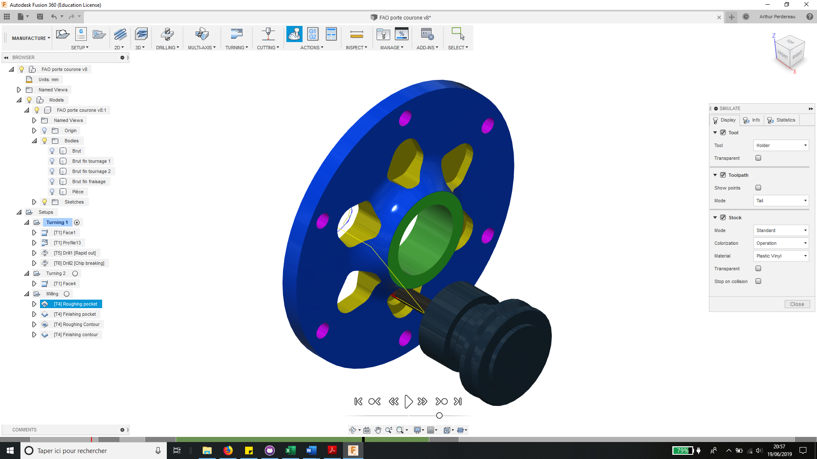

Programming and metrology operation are added separately to the process in order to show the allocation in the part cost. It is also index on volume removed.

The machine is considered to be managed by an operator. During a first part run in the machine, the operator ensures the program do not have any issue. Coefficient are used for multiple parts as the programming is not needed anymore, and the program is validated through the first run.

The programming of the part could be allocated to an operator, a technician or an engineer regarding part complexity. In this case, the metrology of the part is allocated to the same employee.

For conventional machining, the measurements are included in the machining process.



*Laser cutting*

Laser cutting removal rate has been chosen from manufacturer spec sheet of the laser cutter.

As this kind of machine is really efficient, it is difficult to index a programming time on the cut length. Therefore, we assume a constant programming time of 1.5 min per part. It is also applicable for measuring operation, that consist of measuring basic part dimensions like holes diameter.

The setup time is related to a full metal sheet with coefficient as it is more realistic.



*Welding*

***Summary***



